**MY SQL**

set sql_safe_updates=0;

update (seller)

set location= "Mississauga"

where location="Toronto" AND name="Metro";

What is SQL?

* SQL stands for Structured Query Language
* SQL lets you access and manipulate databases
* SQL became a standard of the American National Standards Institute (ANSI) in 1986, and of the International Organization for Standardization (ISO) in 1987

What Can SQL do?

* SQL can execute queries against a database
* SQL can retrieve data from a database
* SQL can insert records in a database
* SQL can update records in a database
* SQL can delete records from a database
* SQL can create new databases
* SQL can create new tables in a database
* SQL can create stored procedures in a database
* SQL can create views in a database
* SQL can set permissions on tables, procedures, and views

Using SQL in Your Web Site

To build a web site that shows data from a database, you will need:

* An RDBMS database program (i.e. MS Access, SQL Server, MySQL)
* To use a server-side scripting language, like PHP or ASP
* To use SQL to get the data you want
* To use HTML / CSS to style the page

## RDBMS

RDBMS stands for Relational Database Management System.

RDBMS is the basis for SQL, and for all modern database systems such as MS SQL Server, IBM DB2, Oracle, MySQL, and Microsoft Access.

The data in RDBMS is stored in database objects called tables. A table is a collection of related data entries and it consists of columns and rows.

Look at the "Customers" table:

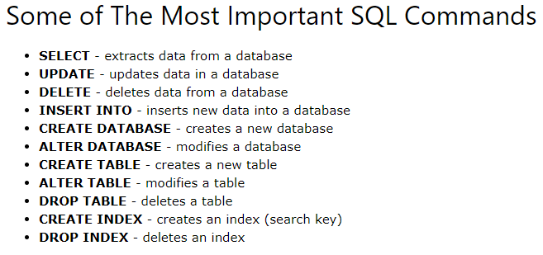

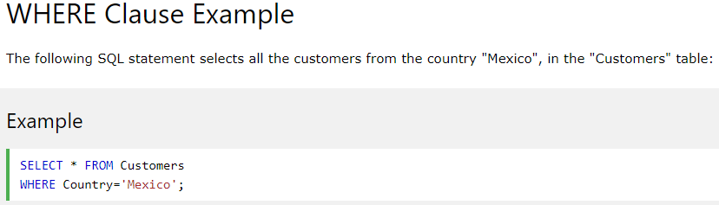

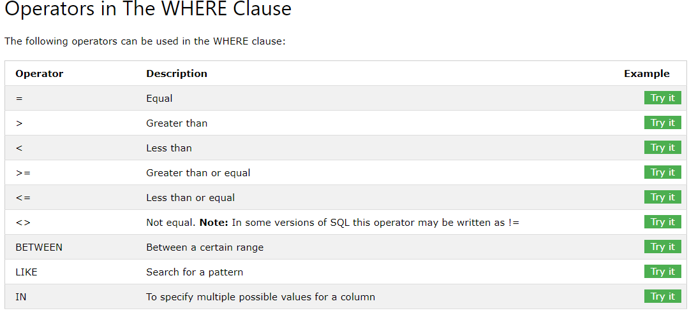

## The SQL AND, OR and NOT Operators

The WHERE clause can be combined with AND, OR, and NOT operators.

The AND and OR operators are used to filter records based on more than one condition:

* The AND operator displays a record if all the conditions separated by AND are TRUE.
* The OR operator displays a record if any of the conditions separated by OR is TRUE.

The NOT operator displays a record if the condition(s) is NOT TRUE.

### **AND Syntax**

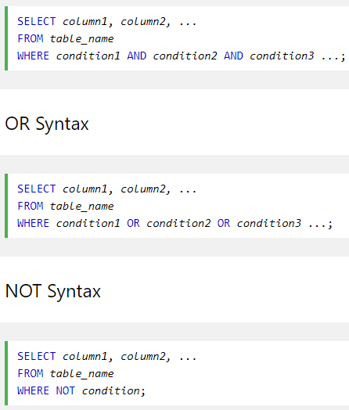

## The SQL AND, OR and NOT Operators

The WHERE clause can be combined with AND, OR, and NOT operators.

The AND and OR operators are used to filter records based on more than one condition:

* The AND operator displays a record if all the conditions separated by AND are TRUE.
* The OR operator displays a record if any of the conditions separated by OR is TRUE.

The NOT operator displays a record if the condition(s) is NOT TRUE.

### **AND Syntax**

### **NOT Syntax**

SELECT column1, column2, ...  
FROM table_name  
WHERE NOT condition;

## Combining AND, OR and NOT

You can also combine the AND, OR and NOT operators.

The following SQL statement selects all fields from "Customers" where country is "Germany" AND city must be "Berlin" OR "München" (use parenthesis to form complex expressions):

### **Example**

SELECT * FROM Customers  
WHERE Country='Germany' AND (City='Berlin' OR City='München');

## The SQL ORDER BY Keyword

The ORDER BY keyword is used to sort the result-set in ascending or descending order.

The ORDER BY keyword sorts the records in ascending order by default. To sort the records in descending order, use the DESC keyword.

### **ORDER BY Syntax**

SELECT column1, column2, ...  
FROM table_name  
ORDER BY column1, column2, ... ASC|DESC;

## The SQL INSERT INTO Statement

The INSERT INTO statement is used to insert new records in a table.

### **INSERT INTO Syntax**

It is possible to write the INSERT INTO statement in two ways.

The first way specifies both the column names and the values to be inserted:

INSERT INTO table_name (column1, column2, column3, ...)  
VALUES (value1, value2, value3, ...);

If you are adding values for all the columns of the table, you do not need to specify the column names in the SQL query. However, make sure the order of the values is in the same order as the columns in the table. The INSERT INTO syntax would be as follows:

INSERT INTO table_name  
VALUES (value1, value2, value3, ...);

## The SQL UPDATE Statement

The UPDATE statement is used to modify the existing records in a table.

### **UPDATE Syntax**

UPDATE table_name  
SET column1 = value1, column2 = value2, ...  
WHERE condition;

## UPDATE Table

The following SQL statement updates the first customer (CustomerID = 1) with a new contact person and a new city.

### **Example**

UPDATE Customers  
SET ContactName = 'Alfred Schmidt', City= 'Frankfurt'  
WHERE CustomerID = 1;

[Try it Yourself »](https://www.w3schools.com/sql/trysql.asp?filename=trysql_update_2)

## UPDATE Multiple Records

It is the WHERE clause that determines how many records will be updated.

The following SQL statement will update the contactname to "Juan" for all records where country is "Mexico":

### **Example**

UPDATE Customers  
SET ContactName='Juan'  
WHERE Country='Mexico';

